Project Impact Narrative: Our World Our Say

Centering Youth Voice at the Intersection of HIV, Environment, and Equity

(See Cammarota & Fine, 2010; Wang & Burris, 1997; Zeldin et al., 2013)
Our World Our Say is a six-year, community-engaged research partnership between Vietnamese youth in Hai Phong, local community organizations, and U.S. university partners. Funded by ESC to advance youth participatory action research (YPAR), the project positions young people impacted by HIV as knowledge producers, artists, and advocates addressing the interconnected challenges of environmental risk, health inequities, and social stigma. Through arts-based methods, most notably Photovoice, youth documented their lived realities, analyzed community-level harms, and translated their insights into public-facing advocacy (Wang & Burris, 1997; Foster-Fishman et al., 2010). Rather than being studied about, youth were engaged with and as co-creators of knowledge, shaping research questions, methods, interpretation, and dissemination.

What We Did: Engaged Methods in Action
This work was grounded in Youth Participatory Action Research (YPAR) and youth–adult partnership frameworks that emphasize shared power, critical consciousness, and action-oriented knowledge production (Cammarota & Fine, 2010; Hart, 1992; Zeldin et al., 2013).
Participatory Research Design
Youth aged 12–19 participated in intensive summer programs where they were trained in photography, ethical storytelling, group dialogue, and creative art-making. Using Photovoice and expanded art forms (printmaking, recycled materials, calligraphy, fiber arts, and film), participants documented environmental degradation, HIV-related stigma, and sources of community pride.
Youth–Adult Partnerships
The project intentionally employed youth–adult partnership principles, redistributing power and centering youth decision-making across all stages of the work. Adult allies served as facilitators and mentors, not directors, supporting youth leadership, analysis, and public engagement.
Public Scholarship and Knowledge Translation
Youth-created art and narratives were curated for public exhibitions in Hai Phong (Vietnam), Louisville (USA), and Seoul (South Korea), and disseminated digitally through short films and online platforms. These spaces functioned as sites of dialogue among youth, community members, policymakers, educators, and health leaders.

What Changed: Evidence of Impact
Consistent with prior research on arts-based and participatory methods, the project produced impacts at individual, relational, and community levels (Braun & Clarke, 2021; Greene et al., 2018).
Youth Empowerment and Leadership
Youth reported increased confidence, self-expression, and a sense of agency in addressing community issues. Through collective analysis, participants articulated concrete, multi-level solutions to environmental and health harms, positioning themselves as change agents rather than passive recipients of services.
Shifting Public Awareness and Attitudes
Audience survey data from exhibition attendees showed a strong impact: nearly all reported improved understanding of youths’ lived experiences. Over 75% reported being emotionally moved and motivated to take action or learn more. Qualitative feedback highlighted increased empathy, reduced stigma, and heightened awareness of environmental injustice.
Disrupting Hierarchies and Creating Dialogue
Exhibitions served as rare intergenerational and cross-sector spaces where youth, particularly those impacted by HIV, were publicly recognized as experts. Researchers documented visible shifts in power dynamics, with policymakers and professionals engaging youth with respect, curiosity, and accountability.

Visual Snapshot of Impact
Visual 1: Youth Codifying Art into Themes
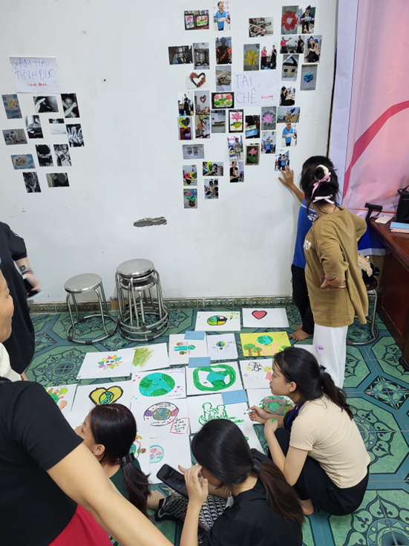
Image: Youth collaboratively clustering photographs and artwork into shared themes.
Message: Knowledge production is collective, embodied, and youth-led.
Visual 2: Environmental Risk Through Youth Eyes
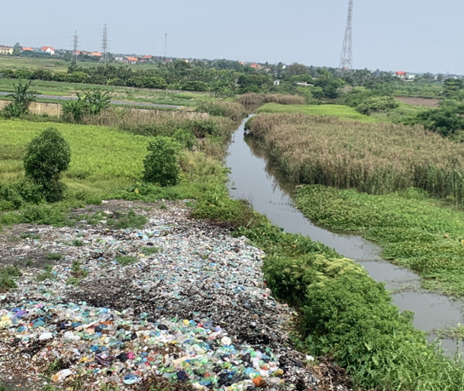
Image: Polluted river and industrial runoff photographed by participants.
Message: Environmental harm as a lived, everyday reality linked to health and livelihood.
Visual 3: HIV Advocacy and Anti-Stigma Messaging
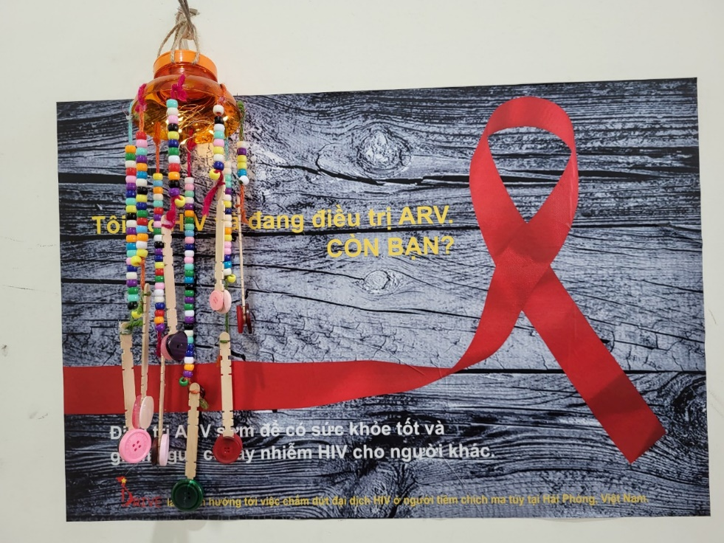
Image: Red ribbon artwork created by youth.
Message: Youth-driven reframing of HIV from shame to solidarity.
Visual 4: Youth as Change Agents Framework “Our World Our Say Youth as Change Agents: Intervening Across Micro, Mezzo, and Macro Levels”
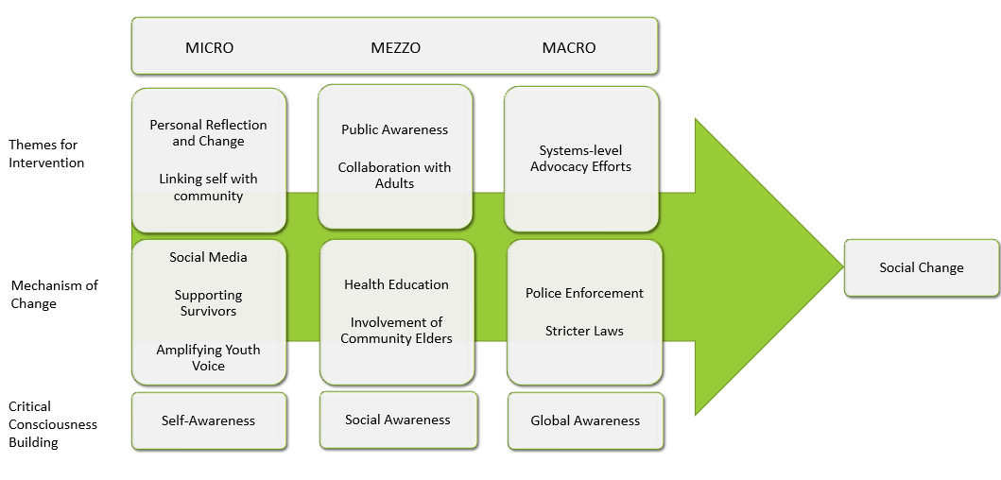
Image: Conceptual graphic illustrating youth-led interventions across micro, mezzo, and macro levels.
Message: Engaged scholarship that moves from reflection to systems-level action.

Why It Matters for Engaged Scholarship
This project aligns with established evidence demonstrating that youth-led, arts-based participatory research can foster empathy, disrupt stigma, and catalyze social change when paired with public-facing dissemination (Hall & Robertson, 2001; Greene et al., 2018; Jenkins, 2016). Our World Our Say exemplifies the core principles of engaged scholarship: reciprocity, co-creation, public relevance, and social impact. The project demonstrates that when research is grounded in community priorities and creative methods, it can simultaneously: a) generate rigorous, publishable knowledge, b) empower communities, c) influence public discourse and policy conversations, and d) train the next generation of civic leaders. By transforming art into evidence and youth into advocates, this funded project advances an ethical, impactful, and globally relevant model of engaged scholarship.
Contact / Project Team
Dr. Lesley M. Harris, University of Louisville, Kent School of Social Work & Family Science: lesley.harris@louisville.edu
Mrs. Hue Pham Thi, Director of HIV & Health Care Support Centre (HHCSC): huepham.hpc@gmail.com

References
Braun, V., & Clarke, V. (2021). Thematic analysis: A practical guide. SAGE.
Cammarota, J., & Fine, M. (2010). Youth participatory action research: A pedagogy for transformational resistance. In J. Cammarota & M. Fine (Eds.), Revolutionizing education (pp. 9–20). Routledge.
Foster-Fishman, P. G., Law, K. M., Lichty, L. F., & Aoun, C. (2010). Youth ReACT for social change: A method for youth participatory action research. American Journal of Community Psychology, 46(1–2), 67–83. https://doi.org/10.1007/s10464-010-9316-y
Greene, S., Burke, K. J., & McKenna, M. K. (2018). A review of research connecting digital storytelling, photovoice, and civic engagement. Review of Educational Research, 88(6), 844–878. https://doi.org/10.3102/0034654318799446
Hall, T., & Robertson, I. (2001). Public art and urban regeneration: Advocacy, claims and critical debates. Landscape Research, 26(1), 5–26.
Hart, R. A. (1992). Children’s participation: From tokenism to citizenship. UNICEF Innocenti Research Centre.
Jenkins, H. (2016). Youth voice, media, and political engagement. In H. Jenkins et al. (Eds.), By any media necessary: The new youth activism (pp. 1–24). NYU Press.
Wang, C., & Burris, M. A. (1997). Photovoice: Concept, methodology, and use for participatory needs assessment. Health Education & Behavior, 24(3), 369–387. https://doi.org/10.1177/109019819702400309
Zeldin, S., Christens, B. D., & Powers, J. L. (2013). The psychology and practice of youth–adult partnership: Bridging generations for youth development and community change. American Journal of Community Psychology, 51(3–4), 385–397. https://doi.org/10.1007/s10464-012-9558-y

